**BEEE LAB FILE**

EXP1: DESIGN AN LED FLASHER

Circuit diagram:

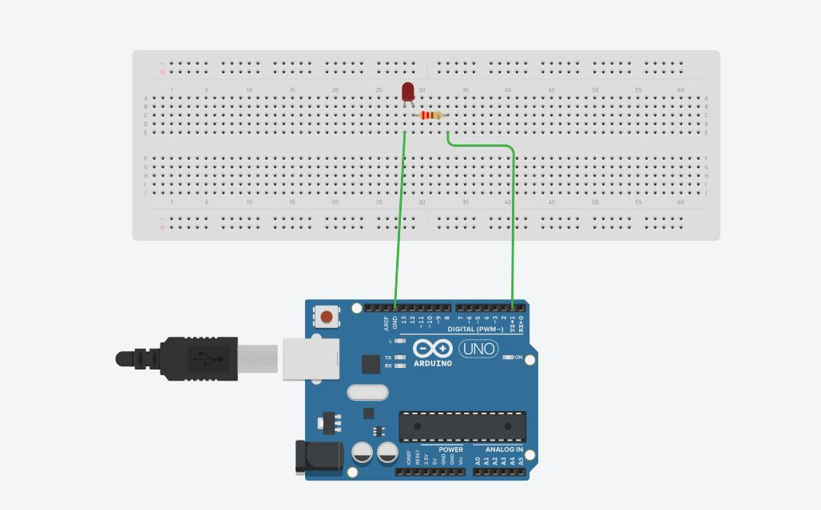

**THEORY**

**CONCEPTS USED:**

1. The use of ARDUINO board and ARDUINO IDE.
2. Use of Ohm's law to calculate value of appropriate resistance for LED.
3. The completion of electric circuits.
4. LED should only be connected in forward bias.
5. The concept of ARDUINO coding for the led flashing.

**LEARNING AND OBSERVATIONS:**

1. Not using a resistance can damage the LED.
2. Using resistance of a very high value may not let the LED GLOW.
3. The circuit needs to be complete to work.
4. Arduino code needs to be without any error in it.
5. Improper connections can lead to circuit breakage.
6. Proper port should be selected in the IDE.
7. The LED needs to be in forward bias.

**PROBLEMS AND TROUBLESHOOTING:**

1. The LED would not glow and then I figured out that the value of resistance was too high, so I used a new resistor of 220 ohm which is a desired value.
2. The code in the ARDUINO IDE was not getting uploaded. The error was that that thru wrong port had been selected in the tools option of the IDE and the problem was troubleshooted successfully by selecting the right COM port.
3. The LED would still not glow and after inspection and observation, it was found that the LED was broken. So the problem was resolved by taking a new LED.
4. The circuit was incomplete as one jumper wire was not properly connected to the breadboard and the problem was resolved by making a good connection.

**PRECAUTIONS:**

1. Make sure to use a resistance of appropriate value.
2. The LED should be connected in forward bias only.
3. Make sure that the equipment being used it dry and is in no proximity of water.
4. Make sure the circuit is not shorted.
5. Make sure the arduino board is not corrupted.

**LEARNING OUTCOMES:**

1. 1. I learnt about the Implementation of ohm's law.
2. I learnt about proper connection of circuits and how to connect them.
3. I now know about the need of resistances in circuits.
4. I now have appropriate Knowledge about the ARDUINO ports and components.
5. I now know the basics of coding in ARDUINO IDE.
6. Now I have appropriate Knowledge about breadboard connections.